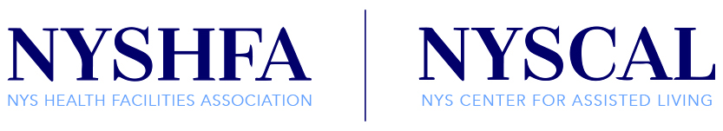
33 Elk Street, Suite 300
Albany, NY 12207
(518) 462-4800 | F: (518) 426-4051
MEMORANDUM IN SUPPORT: S.4042-A (Kaminsky)
The New York State Center for Assisted Living (NYSCAL), represents over 100 Adult Care/Assisted Living Communities across New York State. Our providers serve over 12,000 individuals who are frail, elderly, disabled, and mentally ill. NYSCAL members pride themselves on providing a high level of quality care in programs that enrich the lives of the residents we serve.
On behalf of NYSCAL, we urge the Legislature to pass S.4042-A (Kaminsky). This legislation would provide an essential increase in the State portion of the Supplemental Security Income (SSI) Rate for adult care facilities (ACFs) of $20 per resident per day over a phased in five-year period. This increase is essential to enable ACFs to continue to care for SSI recipients.
An increase in the state portion of the SSI for residents of adult care facilities will ensure continued access to necessary care. The current rate of $40.60 per day is insufficient to provide care, housing, meals, case management, medication assistance, housekeeping, and activities, all of which contribute to providing our residents the best quality of life possible.
Studies conducted with 2013 financial data from NYSCAL, LeadingAge New York, and ESAAL indicate the average cost per day to care for an SSI resident is $69.84 per day. It should be noted these figures were calculated prior to the State’s increase in the minimum wage. While costs, mandates, and health insurance premiums for employees continue to increase dramatically, ACFs have not received a state portion increase in the SSI rate for over a decade.
Given this shortfall, we respectfully request you sign S.4042-A (Kaminsky) and provide Adult Care Facilities a modest, yet much-needed SSI increase of $20 per day over five years. Thank you for your consideration to this important matter.

